# INSTALLING THE REDUX DEVTOOLS

<https://github.com/zalmoxisus/redux-devtools-extension>

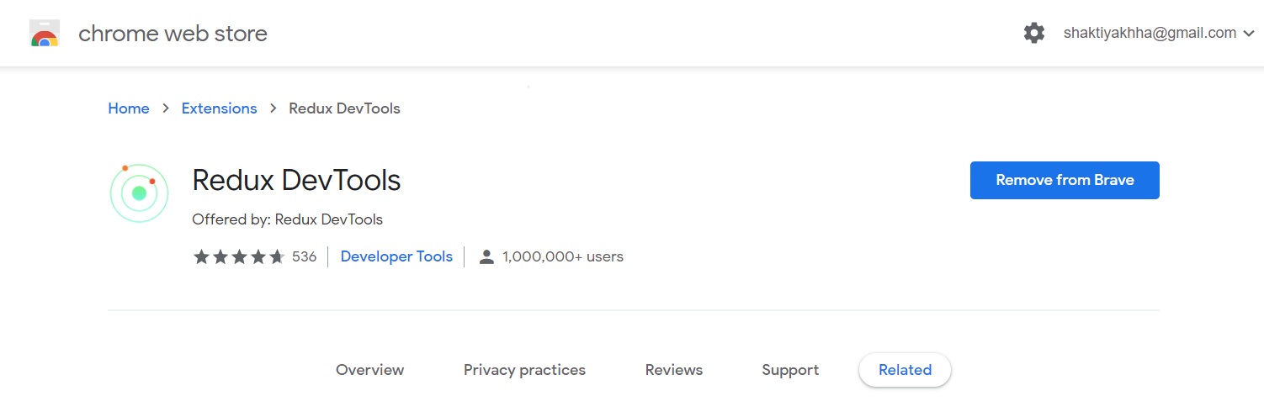

Index.js

const store = createStore(burgerBuilderReducer,

  window.__REDUX_DEVTOOLS_EXTENSION__ && window.__REDUX_DEVTOOLS_EXTENSION__());

# PREPARING THE FOLDER STRUCTURE

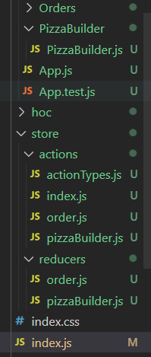

# CREATION ACTION CREATORS

actionTypes.js

export const ADD_INGREDIENTS = 'ADD_INGREDIENTS';

export const REMOVE_INGREDIENTS = 'REMOVE_INGREDIENTS';

pizzaBuilder.js [actions folder]

import * as actionTypes from './actionTypes';

//CHECK BurgerBuilder.js of container folder

export const addIngredient = (name) => {

    return {

        type: actionTypes.ADD_INGREDIENTS,

        ingredientName: name

    };

}

export const removeIngredient = (name) => {

    return {

        type: actionTypes.REMOVE_INGREDIENTS,

        ingredientName: name

    };

}

pizzaBuilder.js [reducers folder]

import * as actionTypes from '../actions/actionTypes';

index.js [main folder]

import React from 'react';

import ReactDOM from 'react-dom';

import './index.css';

import App from './container/App';

import reportWebVitals from './reportWebVitals';

import {BrowserRouter} from 'react-router-dom'

import { Provider } from 'react-redux';

import {createStore} from 'redux';

import burgerBuilderReducer from './store/reducers/pizzaBuilder';

const store = createStore(burgerBuilderReducer);

const app = (

  <Provider store={store}>

    <BrowserRouter>

      <App />

    </BrowserRouter>

  </Provider>

);

ReactDOM.render(app,document.getElementById('root')

);

// If you want to start measuring performance in your app, pass a function

// to log results (for example: reportWebVitals(console.log))

// or send to an analytics endpoint. Learn more: https://bit.ly/CRA-vitals

reportWebVitals();

PizzaBuilder [containers folder]

import * as pizzaBuilderActions from '../../store/actions/index'

const mapDispatchToProps = dispatch => {

    return{

        onIngredientAdded: (ingName) => dispatch(pizzaBuilderActions.addIngredient(ingName)),

        onIngredientRemoved: (ingName) => dispatch(pizzaBuilderActions.removeIngredient(ingName))

    }

}

Index.js[actions folder of store]

export {

    addIngredient,

    removeIngredient

} from './pizzaBuilder';

export {} from './order';

# EXECUTING ASYNCHRONOUS CODE

Install npm install --save redux-thunk

Index.js

import React from 'react';

import ReactDOM from 'react-dom';

import './index.css';

import App from './container/App';

import reportWebVitals from './reportWebVitals';

import thunk from 'redux-thunk';

import {BrowserRouter} from 'react-router-dom'

import { Provider } from 'react-redux';

import {createStore,applyMiddleware,compose} from 'redux';

import burgerBuilderReducer from './store/reducers/pizzaBuilder';

const composeEnhancers = window.__REDUX_DEVTOOLS_EXTENSION_COMPOSE__ || compose;

const store = createStore(burgerBuilderReducer,composeEnhancers(

  applyMiddleware(thunk)

));

const app = (

  <Provider store={store}>

    <BrowserRouter>

      <App />

    </BrowserRouter>

  </Provider>

);

ReactDOM.render(app,document.getElementById('root')

);

// If you want to start measuring performance in your app, pass a function

// to log results (for example: reportWebVitals(console.log))

// or send to an analytics endpoint. Learn more: https://bit.ly/CRA-vitals

reportWebVitals();

# FETCHING INGREDIENTS ASYCNCHORONOUSLY

Revision on your own project from video

# INITIALIZING INGREDIENTS IN THE BURGER BUILDER

Revision on your own project from video

# CHANGING THE ORDER OF OUR INGREDIENTS MANUALLY

Revision on your own project from video

# ADDING ORDER ACTIONS [contact from data]

# CONNECTING CONTACT DATA

# THE ORER REDUCER

# WORING ON ORDER ACTIONS

# REDIRECT TO IMPROVE

# COMBINING REDUCERS

# HANDLING PURCHASES AND UPDATING THE UI

# RESETTING THE PRICE AFTER PURCHASES

# FETCHING ORDERS (VIA REDUX)

# CHECKING OUR IMPLEMENTED FUNCTIONALITIES

# REFREACTORING REDUCES

# REFACTORING REDUCERS CONTINUED

# WRAP UP